1. Introduction
This project presents an advanced Power BI analytical solution designed to transform raw sales data into meaningful business insights. The dashboard enables stakeholders to analyse sales performance, customer behaviour, product trends, and regional distribution to support data-driven decision-making.
The solution includes data cleaning, modelling, DAX calculations, interactive dashboards, and business insights.
PART A: DATA ACQUISITION AND UNDERSTANDING
Dataset Source
The dataset used is the Global Superstore dataset.
Description
The dataset contains sales transaction data including customer information, product details, order dates, regions, and financial metrics such as sales, profit, and quantity.
Key Tables/Fields
- Orders (Fact table): Sales, Profit, Quantity, Order Date
- Customer Table: Customer Name, Segment
- Product Table: Category, Sub-Category, Product Name
- Geography Table: Region, Country, City
Suitability
The dataset is suitable for advanced Power BI analysis because it:
- contains multiple related entities
- supports time-based analysis
- includes numerical and categorical variables
- allows creation of a star schema model

2. Data Cleaning and Preparation

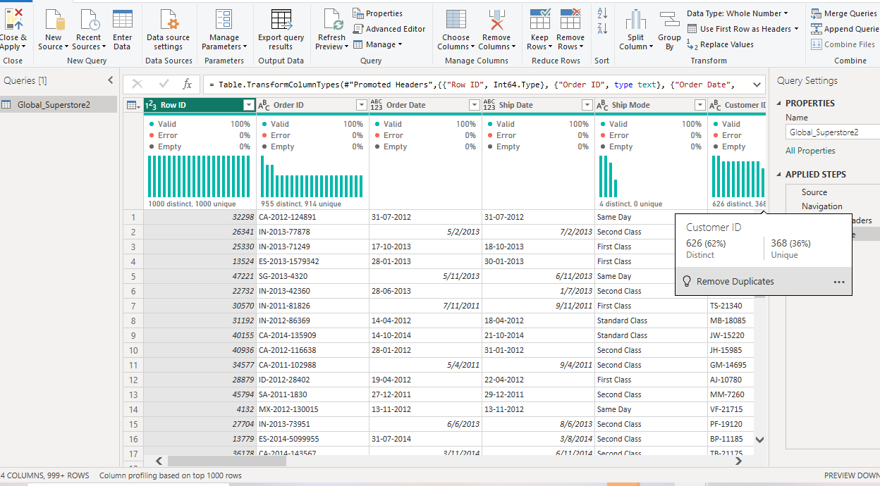
Several data cleaning steps were performed to ensure data quality, consistency, and suitability for analysis.
- Missing values were reviewed and addressed where necessary to ensure completeness of key fields.
- Data types were corrected to ensure numerical fields (Sales, Profit, Quantity, Discount) were properly recognized as numeric values, while date fields were converted into Date format.
- Categorical fields were standardized to ensure consistency across values such as Region, Category, and Segment.
- Unnecessary columns were removed to reduce model complexity and improve performance.
- Data validity checks were performed to ensure that all records represented valid business transactions.
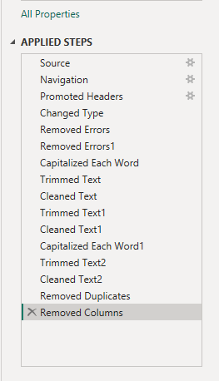
Data after cleaning
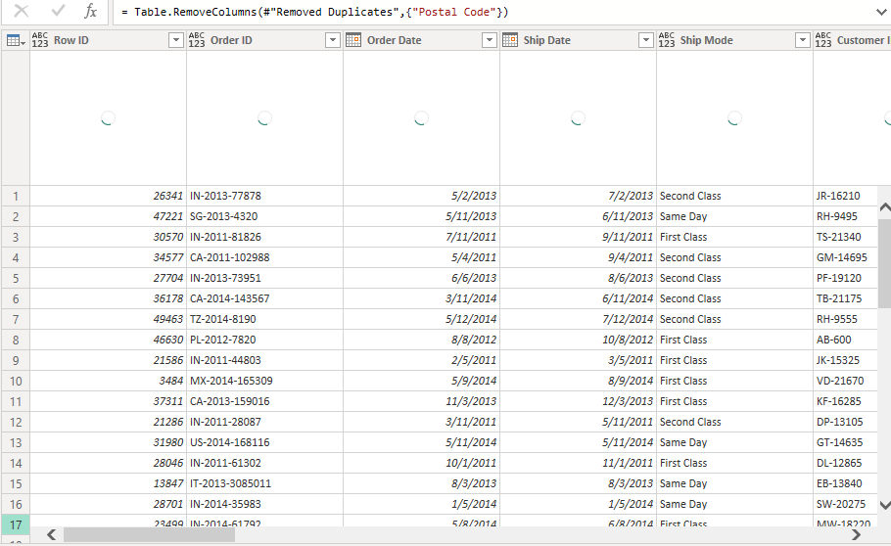
3. Data Transformation Process
Multiple transformation steps were carried out in Power Query to prepare the dataset for analytical modelling.
- The original dataset was used to create separate fact and dimension tables using the reference function.
- Dimension tables including Customer, Product, Geography, and Date were created to represent key business entities.
- Duplicate records in dimension tables were removed to ensure uniqueness.
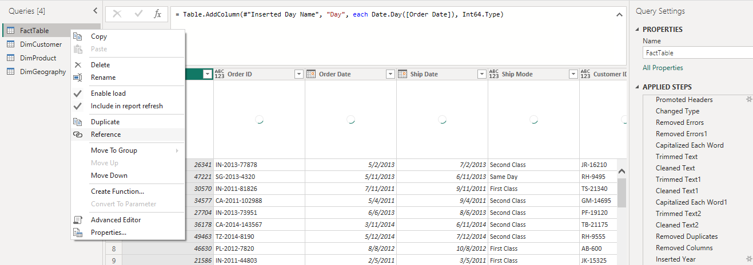
- Column splitting and feature extraction were performed on date fields to derive Year, Month Name, Quarter, and Day Name.

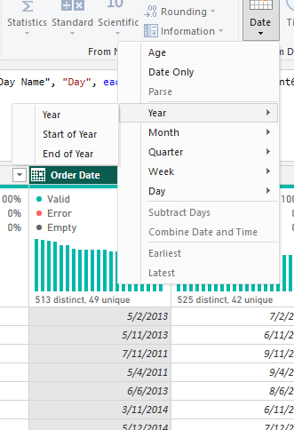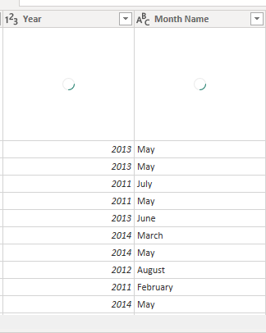
- A Date dimension table was created using a continuous date range to support time intelligence analysis.

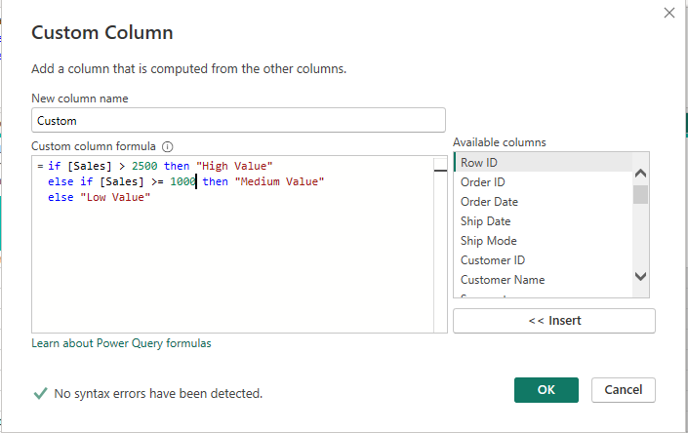
A custom conditional column was created in Power Query to segment sales transactions into three categories: High Value, Medium Value, and Low Value. The classification was based on predefined thresholds applied to the Sales column to enhance interpretability of revenue distribution and support business segmentation analysis.
A total of more than eight meaningful transformation steps were performed in Power Query as required.
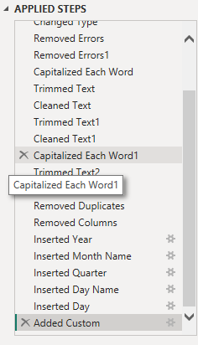
4. Data Modeling
1. Creation of Relationships
A star schema data model was created by establishing relationships between the fact table and multiple dimension tables in Power BI.
The following relationships were created:
- DimCustomer[Customer ID] → FactTable[Customer ID]
- DimProduct[Product ID] → FactTable[Product ID]
- DimGeography[State] → FactTable[State]
- DimDate[Date] → FactTable[Order Date]
These relationships enable filtering and aggregation across different business perspectives.

2. Fact and Dimension Tables Justification
Fact Table: FactTable
The FactTable contains transactional data including Sales, Profit, Quantity, Discount, Order Date, and Ship Date. It represents measurable business events and is used for calculations and aggregations.

Dimension Tables:
DimCustomer
Contains customer-related attributes such as Customer ID, Customer Name, and Segment. It is used to analyse customer behaviour and segmentation.
DimProduct
Contains product-related attributes such as Product ID, Category, and Sub-Category. It supports product-level analysis.
DimGeography
Contains location-based attributes such as City, State, Region, and Country. It enables geographical analysis of sales performance.
Date Table Integration
A separate DimDate table was created and related to the FactTable using the Order Date field. This allows for accurate time-based filtering and supports advanced time intelligence calculations such as yearly trends, monthly performance, and comparative analysis.

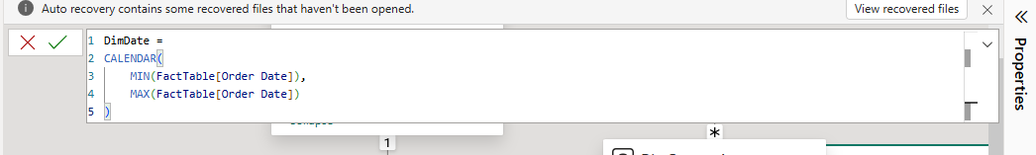
Cardinality and Cross-Filter Direction
All relationships were defined using one-to-many (1:*) cardinality, where each dimension table represents the “one” side and the FactTable represents the “many” side.
The cross-filter direction was set to single direction, flowing from dimension tables to the fact table. This ensures efficient filtering, prevents circular dependencies, and maintains optimal model performance.

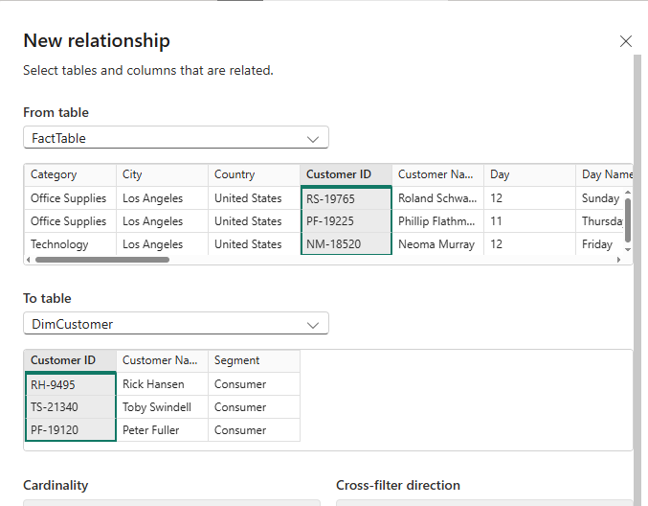

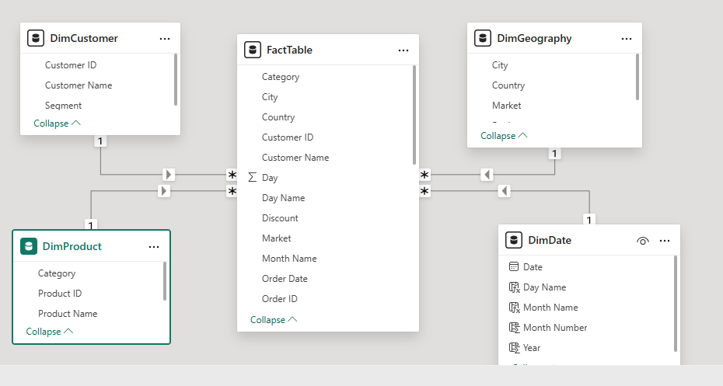
Justification of Model Structure
The star schema structure was chosen because it provides an efficient and scalable data model for analytical reporting. By separating descriptive attributes (dimension tables) from transactional data (fact table), redundancy is reduced and query performance is improved.
This structure also enhances usability in Power BI by enabling intuitive filtering, faster aggregations, and support for advanced analytical functions such as time intelligence and DAX calculations.
Underlying Error: QueryUserError
Activity ID: 8fa0e6bb-936a-4deb-9bc8-52b03b56790c
Time: Sat Apr 18 2026 12:52:09 GMT+0300 (East Africa Time)
5.DAX Measures and Calculated Columns
1. Overview
A set of DAX measures and calculated columns was created to support analytical reporting in Power BI. These calculations transform raw transactional data into meaningful business insights, enabling performance tracking, segmentation, and trend analysis.

Total Sales: Calculates the overall revenue generated from all transactions.
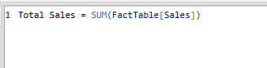
Total Profit:Calculates the total profit.
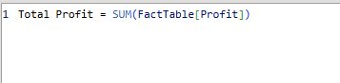

Total Quantity: Measures the total number of items sold.
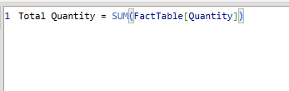
Distinct Customers: Identifies the total number of unique customers.
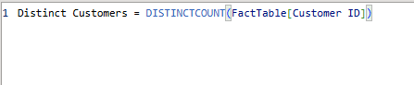
Average Sales per Order: Evaluates the average revenue generated per order.
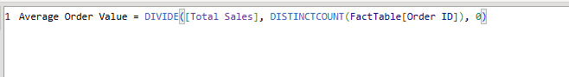
Profit Margin %: Measures profitability efficiency by calculating profit as a percentage of total sales.
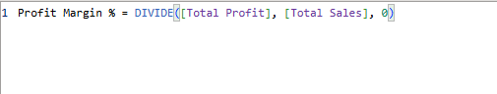
Sales YTD (Year-to-Date): Tracks cumulative sales over the current year using time intelligence
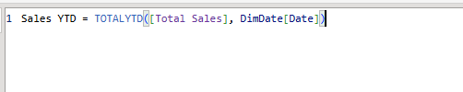
Sales YoY Growth: Compares current sales performance with the previous year to measure growth
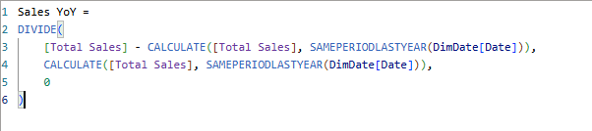
Category Rank: Ranks product categories based on total sales performance using the RANKX function.
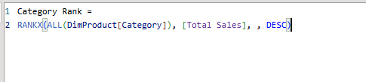
Calculated Columns
Two calculated columns were created to enhance data classification and interpretation
- Profit Status: Classifies each transaction as Profit, Break-even, or Loss based on profit values.

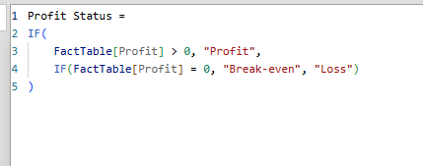
- Shipping Status: Categorises orders into Fast, Normal, or Slow delivery based on the number of days between order date and ship date.
These columns support deeper segmentation and allow for detailed filtering and visual analysis in the dashboard.

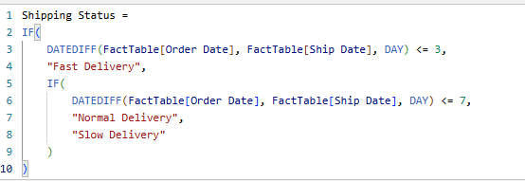
The DAX measures and calculated columns introduce analytical logic into the dataset, enabling dynamic aggregation, ranking, segmentation, and time-based analysis. This enhances the ability to identify trends, evaluate performance, and support decision-making in an interactive Power BI environment.
6.DASHBOARD DESIGN AND VISUALISATION (WORKTHROUGH)
1. Overview of Dashboard Design
The Power BI dashboard was designed to provide a comprehensive analysis of sales performance across multiple dimensions, including time, product categories, customer segments, and geographical regions. The dashboard is structured into multiple pages to support both high-level overview and detailed analytical exploration.
Page 1: Executive Summary
The first page provides a high-level overview of key business metrics and trends.
Key Performance Indicators (KPIs)
The dashboard displays four primary KPIs:
- Total Sales (449K)
- Distinct Customers (264)
- Total Quantity (5K)
- Total Profit (59.09K)
Insights
1. Technology is the leading revenue category
Technology consistently generates the highest sales compared to other categories.
This confirms it is the primary revenue driver of the business.

2. Sales show a steady upward trend over time
The trend chart shows overall growth in sales performance across the time period.
This indicates positive business expansion.

3. Consumer segment dominates sales performance
The Consumer segment contributes the largest proportion of total revenue.
The business is heavily dependent on this segment.

Business Implication
- Focus investment on high-performing categories
- Monitor reliance on Consumer segment
- Maintain strategies that support continuous growth

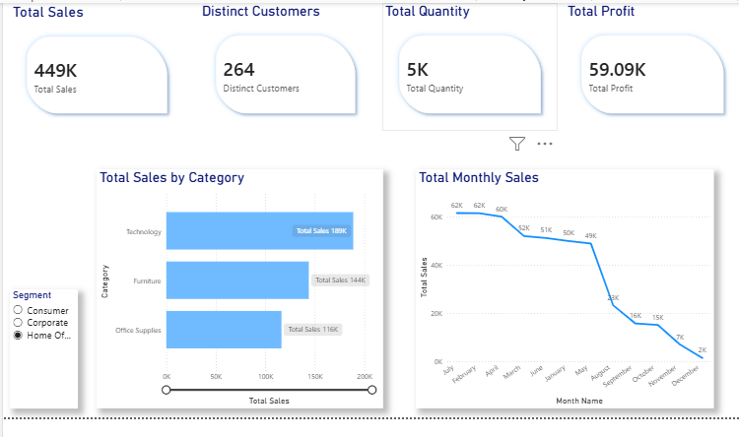
Page 2: Detailed Analysis
This page provides deeper insights into how sales are distributed across different dimensions.
Sales Breakdown (Sankey Diagram)
The Sankey diagram visualizes the flow of sales across multiple dimensions:
- From Region
- to Category
- to Segment
This allows users to understand how revenue is distributed across hierarchical relationships.
The visual also supports filtering, enabling focused analysis such as examining sales flow within a specific region (e.g., Oceania) and category (e.g., Technology).

Sales by Segment (Donut Chart)
This visual shows the proportional contribution of each customer segment:
- Consumer: 51% (largest segment)
- Corporate: 30%
- Home Office: 18% (smallest segment)
This helps identify the most valuable customer groups.
Matrix (Region vs Category)
The matrix provides a detailed numerical breakdown of sales across regions and product categories.
This allows users to:
- view exact values,
- compare performance across regions,
- and validate insights derived from other visuals.
The trend chart shows overall growth in sales performance across the time period.
This indicates positive business expansion.

Insights
Regional performance is uneven
Sales are concentrated in specific regions such as North America and Europe.
This shows strong but uneven market penetration.

Revenue is driven by a small number of products
Products like Copiers and Phones contribute significantly to total sales.
Indicates dependency on a few high-performing products.

Corporate and Home Office segments underperform
These segments contribute significantly less compared to Consumer.
Suggests untapped B2B market potential.

Business Implication
- Expand into underperforming regions
- Diversify product dependency
- Strengthen Corporate and Home Office targeting strategies

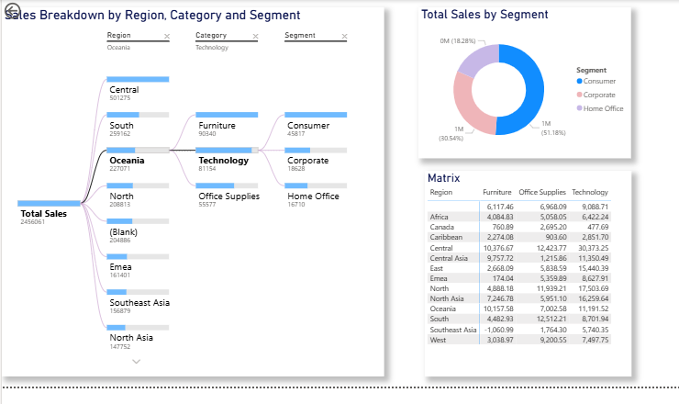
Page 3: Insights and Performance Monitoring
This page focuses on deeper performance evaluation and trend analysis.

Sales by Sub-Category
This visual further breaks down category-level performance into sub-categories.
It reveals that:
- Copiers and Phones are the top-performing sub-categories.
This supports product-level decision-making.

Sales and Profit Comparison (Gauge Chart)
The gauge chart attempts to compare total sales and total profit.
- Total Sales is represented by the main arc (~2M),
- Profit is shown as a smaller marker (~305K).
Insights
Profit does not scale proportionally with sales
Despite strong sales performance, profit growth is lower.
Indicates potential inefficiencies in cost or pricing structure.

Sales growth is consistent but uneven
Some periods show stronger performance than others.
Suggests seasonal or cyclical demand patterns.

Product performance is highly concentrated
A small group of products dominates revenue contribution.
Creates risk of over-dependence.

Business Implication
- Improve profit margin strategies
- Use seasonal trends for planning
- Reduce over-reliance on top product

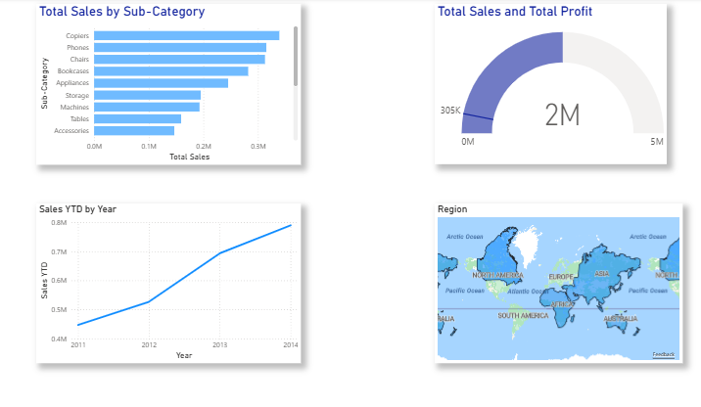
5. Tooltip Page
A tooltip page was implemented to enhance interactivity and provide additional insights without overcrowding the dashboard.
When users hover over visuals, the tooltip displays:
- Average Order Value (365.65)
- Profit Margin (12%)
This allows users to access deeper insights contextually, improving user experience and analytical depth.

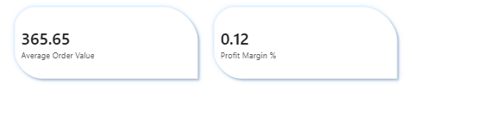

- ANALYTICAL INSIGHTS

Insight 1: Strong Dependence on Technology Category
The Technology category consistently outperforms other categories in total sales contribution, making it the primary revenue driver.
Deeper interpretation:
This indicates that the business is heavily reliant on a single product category for revenue generation. While this is currently beneficial, it introduces a structural risk where any decline in Technology demand could significantly impact overall performance.
Insight 2: Customer Base is Highly Concentrated in Consumer Segment
The Consumer segment contributes more than half of total sales compared to Corporate and Home Office segments.
Deeper interpretation:
This suggests limited diversification in customer targeting. The business is exposed to demand fluctuations within the Consumer market, while B2B segments (Corporate and Home Office) remain underdeveloped.
Insight 3: Consistent Upward Sales Trend Over Time
Sales show a steady increase across the observed time period, indicating sustained business growth.
Deeper interpretation:
This trend suggests either improved market penetration, effective sales strategies, or increasing demand. However, without proportional profit growth analysis, revenue growth alone does not confirm improved financial efficiency.
Insight 4: Regional Performance Imbalance
Sales are heavily concentrated in specific regions such as North America and Europe, while other regions contribute significantly less.
Deeper interpretation:
This indicates uneven market penetration. Some regions may be fully developed markets, while others remain underexploited. This creates an opportunity for geographic expansion and revenue diversification.

Insight 5: Revenue Concentration in Few High-Performing Products
A small number of sub-categories (e.g., Copiers, Phones) contribute a disproportionately large share of total sales.
Deeper interpretation:
This demonstrates a lack of product diversification in revenue generation. Over-reliance on a few high-performing products creates risk if market demand shifts or competition increases in those segments.
Insight 6: Profitability Does Not Scale Proportionally with Sales
Although sales figures are high, profit margins appear relatively smaller in comparison.
Deeper interpretation:
This suggests potential inefficiencies in pricing strategy, cost structure, or discounting practices. It highlights the need for improved profit optimization rather than focusing solely on revenue growth.
Insight 7: Segment Performance Gap Indicates Untapped B2B Opportunity
Corporate and Home Office segments show significantly lower contribution compared to Consumer.
Deeper interpretation:
This indicates an underutilised business-to-business (B2B) opportunity. Strengthening these segments could lead to more stable and predictable revenue streams.

Insight 8: Seasonal Variation in Sales Activity
The monthly sales trend indicates fluctuations across different periods of the year.
Deeper interpretation:
This suggests possible seasonality in demand, which could be leveraged for inventory planning, marketing campaigns, and promotional strategies.
2. BUSINESS RECOMMENDATIONS

Recommendation 1: Diversify Revenue Beyond Technology
The business should reduce over-dependence on the Technology category by strengthening Furniture and Office Supplies through product expansion and targeted marketing.
Business impact:
This reduces revenue risk and improves long-term stability.

Recommendation 2: Strengthen Corporate and Home Office Segments
Targeted marketing strategies, discounts, and tailored product offerings should be introduced for non-Consumer segments.
Business impact:
This increases customer base diversity and improves revenue predictability.

Recommendation 3: Expand into Underperforming Regions
Regions with low sales contribution should be targeted through localized marketing strategies, partnerships, and distribution improvements.
Business impact:
This opens new revenue streams and reduces geographic dependency risk.
Recommendation 4: Improve Profit Margin Efficiency
The business should review pricing strategies, discount policies, and operational costs to ensure profit growth aligns with sales growth.
Business impact:
This ensures revenue growth translates into actual financial performance improvement.
Recommendation 5: Reduce Dependency on Top-Selling Products
The company should invest in developing mid-performing products to balance revenue distribution.
Business impact:
This reduces risk exposure to market changes affecting key products like Copiers and Phones.
Recommendation 6: Leverage Seasonal Trends for Planning
Sales fluctuations over time should be used to optimise inventory levels, marketing campaigns, and promotional timing.
Business impact:
This improves operational efficiency and reduces stock or demand mismatch.

